《在线课堂》学习单
班级： 姓名：
单元 | 英语4年级上册Unit 6
课题 | Toys (Vocabulary and Target)
温  故  知  新 | Read and write. 补充单词。  1.t___y 2.p___zzle 3.g___m____  4.dr____m 5.b___ ___ r 6. c____r  7.pl__n___ 8.c____mp____ter 9.d____ll
自  主  攀  登 | Read and write. 根据句意，写单词。  1. What do you want?  I want a________________ .（玩具汽车）  2. Do you want a__________(吉他)?  Yes, please.  3. Does he want a ________________(玩具飞机)？  No. he doesn’t.
稳  中  有  升 | Read and write. 看图填空  1.What do you want? I want a __________.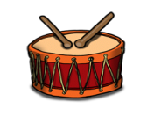  2.What do they want? They want a_________ ________? 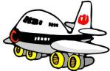  3.Do you want a __________? No, I don’t. I want a drum. 4. Does she want a ____________? Yea, she does. 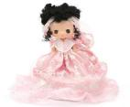
说句心里话

