《在线课堂》学习单
单元 | 英语三年级上册 Unit8 Sport
课题 | Vocabulary and Target
温  故  知  新 | 一、写出相应的单词。  - 乒乓球 2. 喜欢 3. 网球 4. 棒球
自  主  攀  登 | 1、我会读：听录音,读课本P49单词和对话3次。  2、我会练：  一、抄写下列单词。  baseball do soccer  二、圈出首字母。  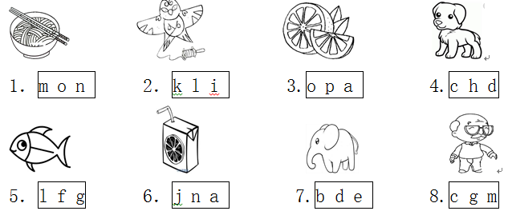
稳  中  有  升 | - 完成短文。 Fill the blanks.  In the garden, Tony, Jenny and Gogo are talking about the sport. Tony and Gogo like ______ (Ping-pong / soccer) and ________(baseball / basketball). Does Jenny like soccer? ___(Yes / No), she doesn’t. She likes ________(baseball / tennis). So they play baseball together. Hurray!
说句心里话
班级： 姓名：

