 《在线课堂》学习单
班级： 姓名：
单元 | 四年级下册Unit 7 Hobbies
课题 | Story
温  故  知  新 | Choose and write.选词填空。  Where  What  like  1.-________are you going? –I am going to the beach.  2.-________are you doing? – I am playing the guitar.  3.- What do you like?  -I__________ a violin.
自  主  攀  登 | Look and write. 看图填空。  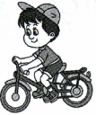  1.-What’s your hobby?  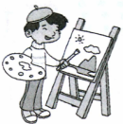  -My hobby is _________ a bike.  2.-What are you doing?  -I am_______________..  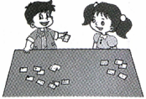  3.-What do you like doing?  -I like playing____________.  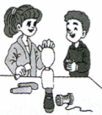  4.-Do you like making__________?  - Yes, I do.
稳  中  有  升 | Read, choose and write.选词填空。  A: What do you do ?  B: I am a ____________.  story read  stars student  A: What are you doing?  B: I am reading a __________about ____________.  A: Is it interesting?  B: Yes, it is. Do you want to ____________it?  A:Yes,I do.
说句心里话

