《在线课堂》学习单
班级 姓名
单元 | 英语六年级下册 Unit 5 Being Helping
课题 | U5单词
温  故  知  新 | 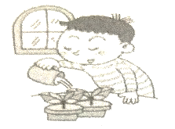  看图选词填空。  washing the clothes cleaning the windows watering the plants  1.A: Is he ?  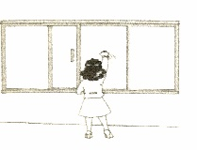  B: Yes, he is.  2.A: What is she doing?  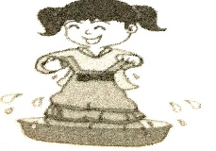  B: She is .  3.A: Are you ?  B: Yes, I am.
自  主  攀  登 | 中英文匹配。  1. ( ) turn on the light A.关电视  2. ( ) turn off the TV B.扔垃圾  3. ( ) put away your books C.开灯  4. ( ) take out your notebook D.打扫房间  5. ( ) take out the trash E.拿出笔记本  6. ( )put on your jacket F. 挂衣服  7. ( ) hang up your clothes G.穿上夹克衫  8. ( ) clean up the room H. 收拾好你的书本
稳  中  有  升 | 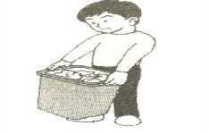  看图，完成对话。  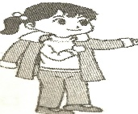  1. -Can you the trash?  Because I heard someone knocking at the door  2. –Don’t forget to your coat.  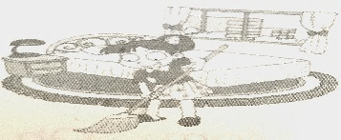  - OK.  3. –What did you do yesterday?  I the room.
说句心里话

