 《在线课堂》学习单
班级： 姓名：
单元 | 四年级下册Unit 5 Our Clothes
课题 | V&T
温  故  知  新 | Choose and write.选词填空。  Is Are Whose May  1.-______this your toy car? –No, isn’t.  2.-______these your puzzles? –Yes, they are.  3.-_______computer is it? –It’s Lisa’s computer.  4,-__________ I have a pen ? -Yes ,you may.
自  主  攀  登 | Look and write.看图填空。  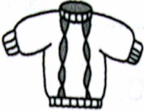  - This is your_____________.  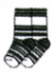  - These are my sister’s_______________.  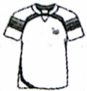  - I want to buy a ______________.  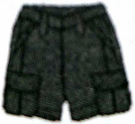  - Whose ____________are these?
稳  中  有  升 | Read and choose.选出相应的答句。  A: Yes, they are.  B: It’s mine.  C. No, it isn’t. It’s Tony’ s .  D. They’re your father’s.  E. It’s red.  ( ) 1. Is this your shirt?  ( ) 2.Are these Mom’s shoes?  ( ) 3. Whose blue pen is this?  ( ) 4.What color is the dress?  ( ) 5.Whose shoes are these?
说句心里话

