《在线课堂》学习单
班级： 姓名：
单元 | 四年级下册Unit 5 Our Clothes
课题 | Story
温  故  知  新 | Choose and write.选词填空。  this these  whose  1.________is her dress  2.________are his shoes.  3.-__________cap is it?  -It’s Tom’s.
自  主  攀  登 | Look and write. 根据句意，选择图片填空。  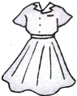  1.-Whose_______is this?  -It’s Jenny’s  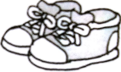  2.-Are these your___________?  -No, they aren’t. They are my brother’s.  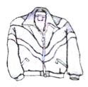  3.-Is this your___________?  -Yes, it is.  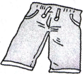  4.-Whose___________are these?  - They are Tony’ s.
稳  中  有  升 | Read, choose and write.选词填空。  mine shirts Whose cap  A: Tony, these are your__________ and a sweater. Here you are.  B: Thank you, Jenny.  A: The dress and the coat are ___________. ______________ pants are these?  B: They are Goo’s. And this____________ is his, too.
说句心里话

