《在线课堂》学习单
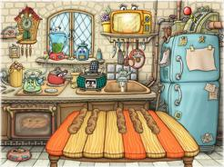
班级： 姓名：
单元 | 四年级下册Unit 4 Free Time
课题 | Vocabulary and Target
温  故  知  新 | Look, choose and write.看图选词填空。  go to the zoo watch TV call my friend  1.______________ 2._________________ 3._________________  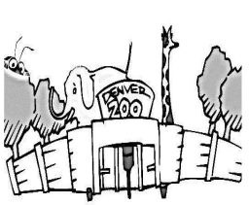  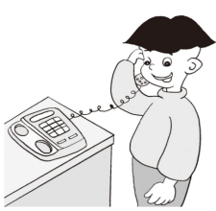
自  主  攀  登 | Choose and write.选词填空。  have call like watch  1.May I _________________TV?  2.I_____________balloons.  3.May I ______________a ruler?  4.You can ___________your friend.
稳  中  有  升 | Read and choose.选出相应的答句。  - You’re welcome!  - Yes, you may.  - I’m going to the library  - I’m moving to a new home.  - No,I don’t.  ( ) 1. May I buy an ice cream?  ( ) 2.Thank you!  ( ) 3. Do you like balloons?  ( ) 4.Where are you going?  ( ) 5.What are you doing?
说句心里话

